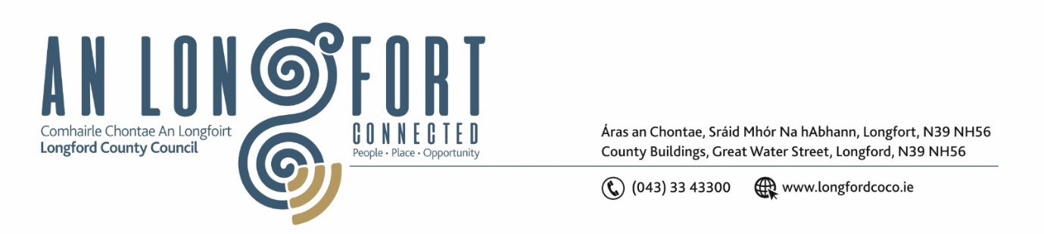

**LONGFORD MUNICIPAL DISTRICT**

***Please note meeting will be held in the Council Chamber, Aras an Chontae and via Microsoft Teams***

**25 April 2023.**

**To: Each Member of Longford Municipal District.**

**Dear Member,**

You are requested to attend the Meeting of Longford Municipal District to be held in **the Council Chamber, Aras an Chontae** and **via Microsoft Teams** on **Wednesday 3 May 2023 at 3.30pm** to transact business, as set out on the agenda hereunder.

**Yours sincerely**,

_______________

**Claire McNabola**

**Meetings Administrator**

**AGENDA**

Prayer before meeting.

**1.** Confirmation of Minutes:

1. Longford Municipal District Meeting held on Wednesday 22 March 2023 – enclosed.
2. Longford Municipal District In Committee Meeting held on Wednesday 22 March 2023 – enclosed.

**2.** Matters arising from Minutes.

**3.** Declaration of Interest by Members.

**4.** Management Report – enclosed.

**5.** Consideration of Draft Bye Laws – Street Service Vehicles

**6.** Nomination from Longford Municipal District to the Place Naming Committee

**7**. Consideration of Part VIII No. 105 Construction of a School Zone and ancillary works at Scoil Mhuire Newtownforbes, Co. Longford, along the L-1004-0 Road and the construction of a new controlled crossing on the N4 at Newtownforbes, Co. Longford – to follow

**8.** **Notices of Motions, submitted by Councillors, as listed hereunder –**

**Councillor Uruemu Adejinmi**

1. I call on Longford County Council to provide shelter and sitting at the bus stops in Longford MD for people waiting to take the bus.
2. I call on Longford County Council to have an ISL interpreter present at Longford MD meetings to make meetings accessible to a wider audience viewing online or in person.

**Councillor Seamus Butler**

1. That Longford Municipal District will set aside sufficient funds for the Twinning trip to Noyal Chatillon-sur Seiche to cover travel and expenses in June 2023.
2. That a speed bump be installed on the main road in Ardnacassa Lawns due to accidents occurring and anti-parking bollards be installed along the main road footpath in Ardnacassa from the entrance of Midara Gardens to the corner at the Dublin Road to prevent HGVs and other vehicles parking on the footpath.

**Councillor John Browne**

1. I call on Longford County Council to resurface the area in front of the Train/ Bus Station at Convent Road, Longford.